Integrated Development Environment (IDE) is a software application/platform that provides a unified environment for programmers to carry out various tasks in the software development lifecycle. Here are key points about IDE and related topics:
1. Definition of IDE:
- Integrated environment for coding, building, debugging, packaging, and deploying code.
- Supports multiple programming languages.

2. Why Use IDE:
- Centralized Coding Environment:
- Allows writing, testing, and debugging code in one place.
- Offers a comfortable coding experience.

- Advantages Over Text Editors:
- In a text editor (like a notebook or command line), you'd need separate tools for each task.
- IDE consolidates all these tasks in one platform.

3. Capabilities of IDE:
- Code analysis, graphical debugger, unit testing, version control, project management, collaboration, efficiency, and resource management.

4. Types of IDE:
- Examples include PyCharm, Anaconda (for data science), Google Colab.

5. PyCharm:
- Invented by JetBrains, widely used and acclaimed IDE.

6. Omni Shortcuts in PyCharm:
- Back: Ctrl+Alt+Left
- Right: Ctrl+Alt+Right
- Class: Ctrl+N (Lists all classes created in projects)
These shortcuts is also available in Navigate bar.
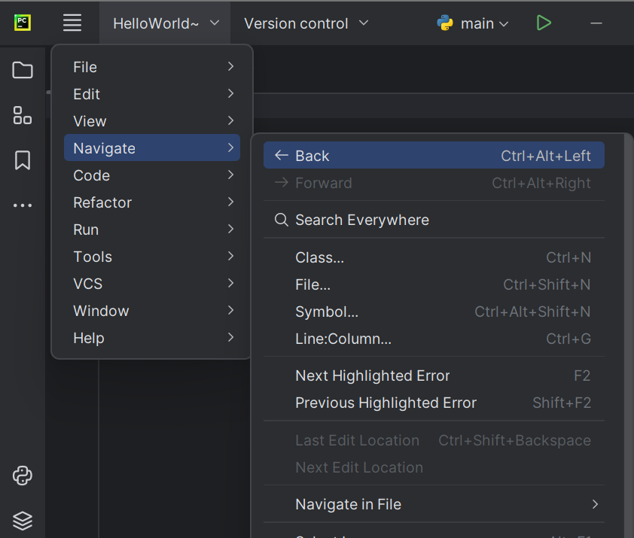

7. Navigate Macro in PyCharm:
- How to go to declaration: Navigate declaration.
- Search everywhere
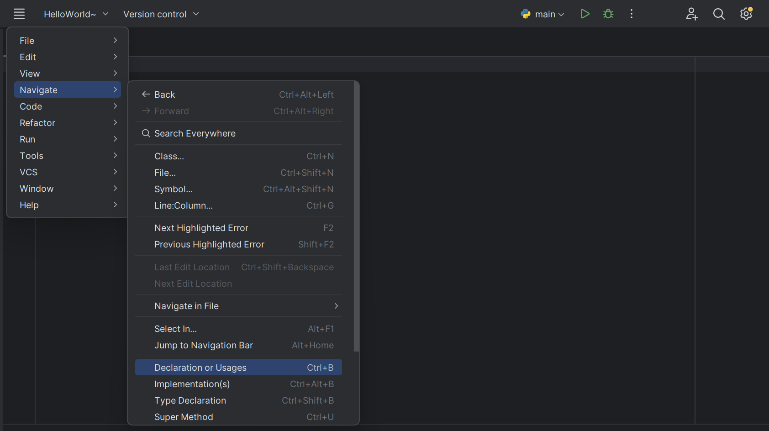

8. Micro Options in Projects:
- Options from the source/opened file.
- Expand all, collapse all.
- Show options menu.
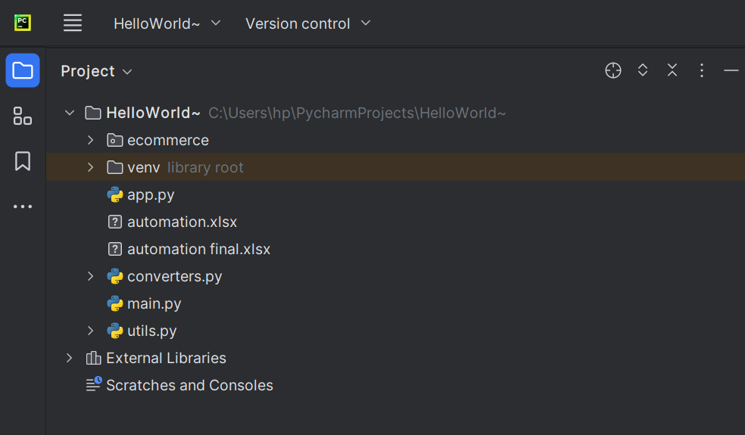

9. Code Improvement Shortcuts:
- Improve Code Completion: Ctrl + Spacebar
- Intention Action: Alt + Enter

10. Sample Program to Find Square Root:
num = float(input('Enter a number: '))
sqrt = num ** 0.5
print('The square root of', num, 'is', sqrt)

- Debug option is in the run menu.
- Breakpoints can be set in the run menu, useful for breaking long codes into modules.
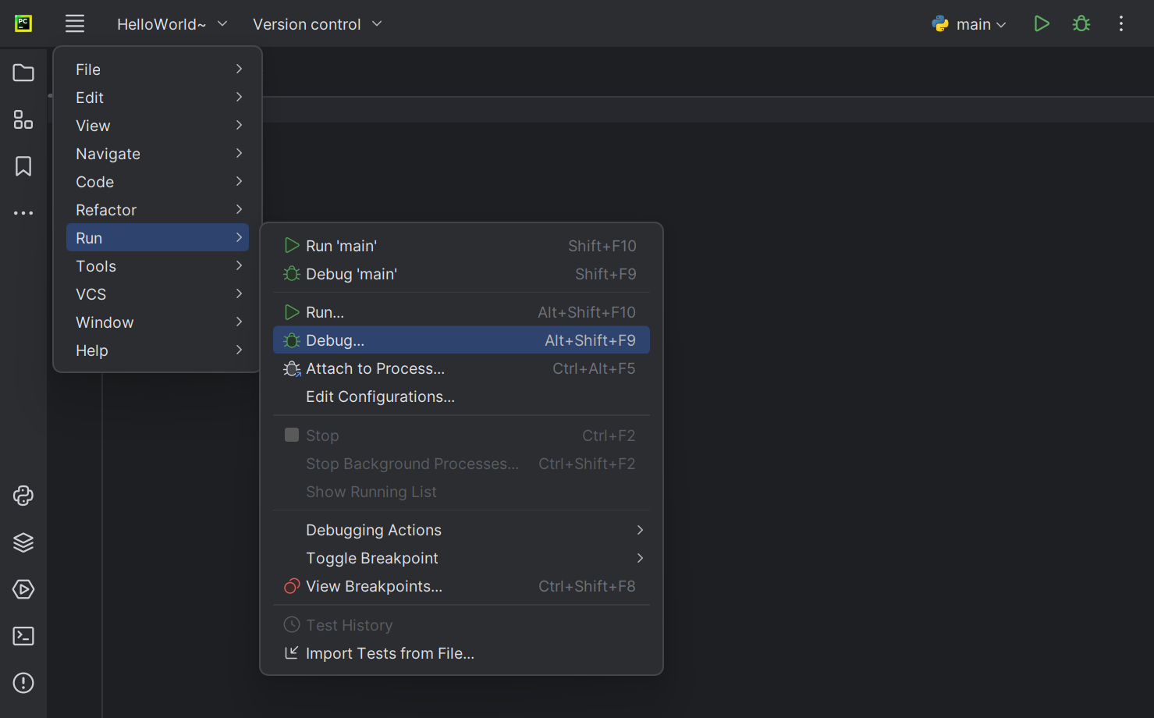
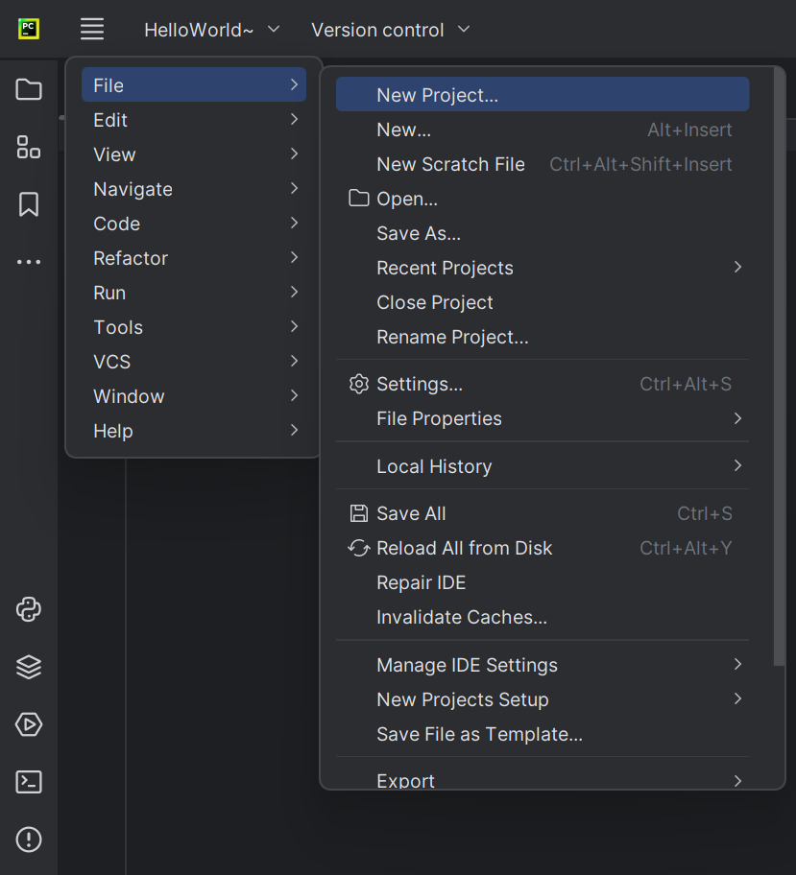
By going to file tab, you can create new project. And by clicking new in file tab, you can create a new file, new python file, new html file etc.
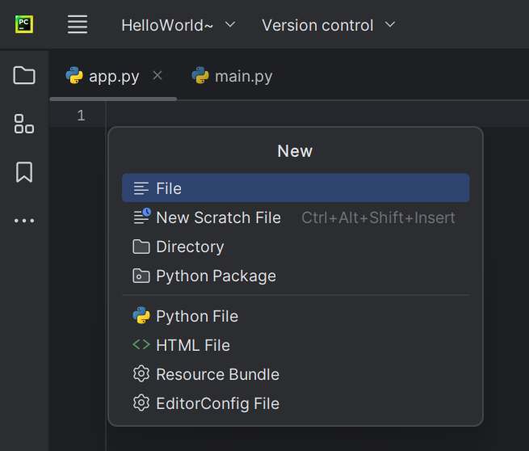

In run menu, we have rum, debug and breakpoint option.
To view/create a breakpoint we can use the shortcut – Ctrl+Shift+F8 or directly click the breakpoint option in run tab.
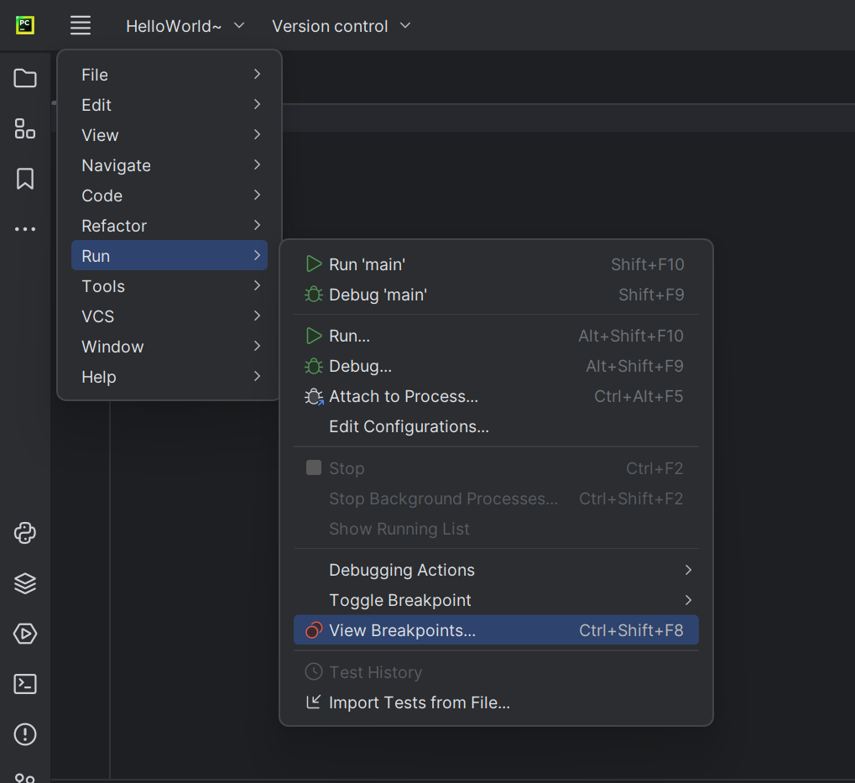
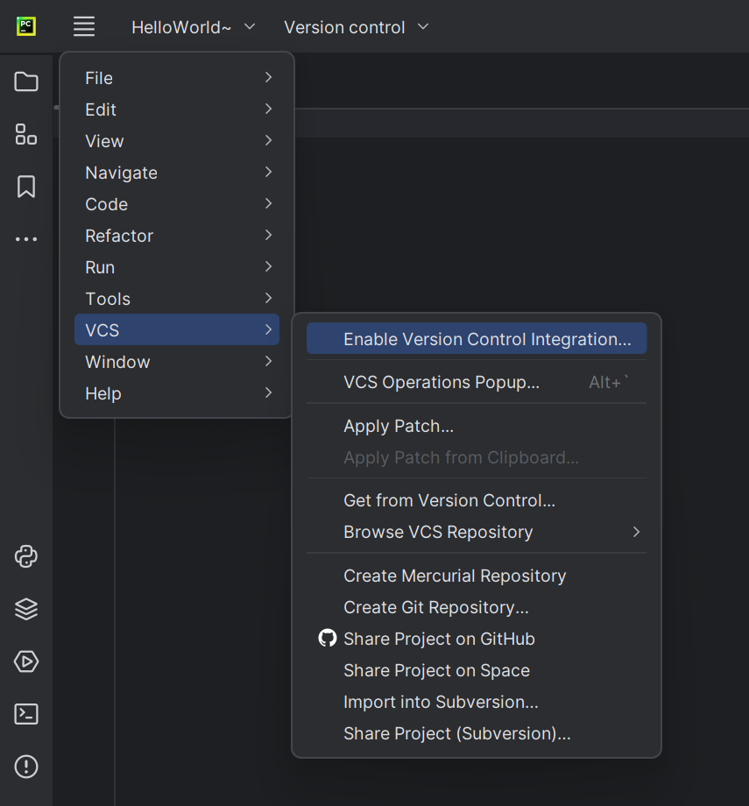
In VCS tab, you have the options to create/import different repositories like Git, Mercurial, Subversion, Space etc.
